**ARYAMAN MISHRA**

**19BCE1027**

**1)Best Fit**

#include<stdio.h>

#include<conio.h>

#define max 25

int main()

{

int frag[max],b[max],f[max],i,j=0,nb,nf,temp,lowest=10000,x,alloc[max];

static int bf[max],ff[max];

printf("\nEnter the number of blocks:");

scanf("%d",&nb);

printf("Enter the number of files:");

scanf("%d",&nf);

printf("\nEnter the size of the blocks:-\n");

for(i=1;i<=nb;i++)

{

printf("In Use(1) or Free Memory(0):");

scanf("%d",&x);

if(x==0)

{

printf("Block %d:",j+1);

scanf("%d",&b[j]);

j++;

}

else

{

printf("Block %d:",j+1);

scanf("%d",&alloc[i]);

j++;

}

}

printf("Enter the size of the files :-\n");

for(i=1;i<=nf;i++)

{

printf("File %d:",i);

scanf("%d",&f[i]);

}

for(i=1;i<=nf;i++)

{

for(j=1;j<=nb;j++)

{

if(bf[j]!=1)

{

temp=b[j]-f[i];

if(temp>=0)

if(lowest>temp)

{

ff[i]=j;

lowest=temp;

}

}

}

frag[i]=lowest;

bf[ff[i]]=1;

lowest=10000;

}

printf("\nFile No\tFile Size \tBlock No\tBlock Size\tFragment");

for(i=1;i<=nf && ff[i]!=0;i++)

printf("\n%d\t\t%d\t\t%d\t\t%d\t\t%d",i,f[i],ff[i],b[ff[i]],frag[i]);

getch();

return 0;

}

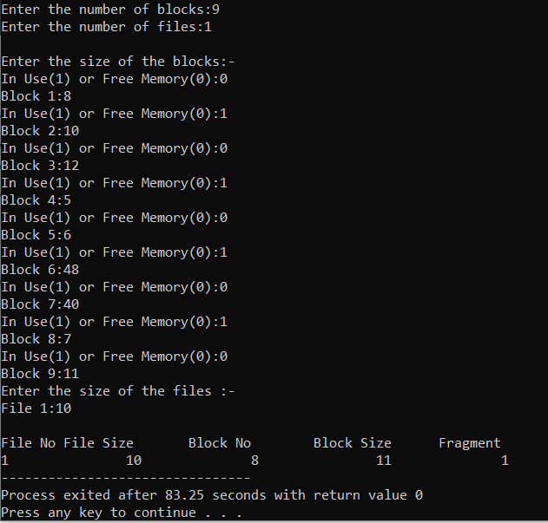

**2)First Fit**

#include<stdio.h>

#include<conio.h>

#define max 25

int main()

{

int frag[max],b[max],f[max],i,nb,nf,temp,x,j=0,alloc[max];

static int bf[max],ff[max];

printf("\n\tMemory Management Scheme - First Fit");

printf("\nEnter the number of blocks:");

scanf("%d",&nb);

printf("Enter the number of files:");

scanf("%d",&nf);

printf("\nEnter the size of the blocks:-\n");

for(i=1;i<=nb;i++)

{

printf("In Use(1) or Free Memory(0):");

scanf("%d",&x);

if(x==0)

{

printf("Block %d:",j+1);

scanf("%d",&b[j]);

j++;

}

else

{

printf("Block %d:",j+1);

scanf("%d",&alloc[i]);

j++;

}

}

printf("Enter the size of the files :-\n");

for(i=1;i<=nf;i++)

{

printf("File %d:",i);

scanf("%d",&f[i]);

}

for(i=1;i<=nf;i++)

{

for(j=1;j<=nb;j++)

{

if(bf[j]!=1)

{

temp=b[j]-f[i];

if(temp>=0)

{

ff[i]=j;

break;

}

}

}

frag[i]=temp;

bf[ff[i]]=1;

}

printf("\nFile_no:\tFile_size :\tBlock_no:\tBlock_size:\tFragement");

for(i=1;i<=nf;i++)

printf("\n%d\t\t%d\t\t%d\t\t%d\t\t%d",i,f[i],ff[i],b[ff[i]],frag[i]);

getch();

return 0;

}

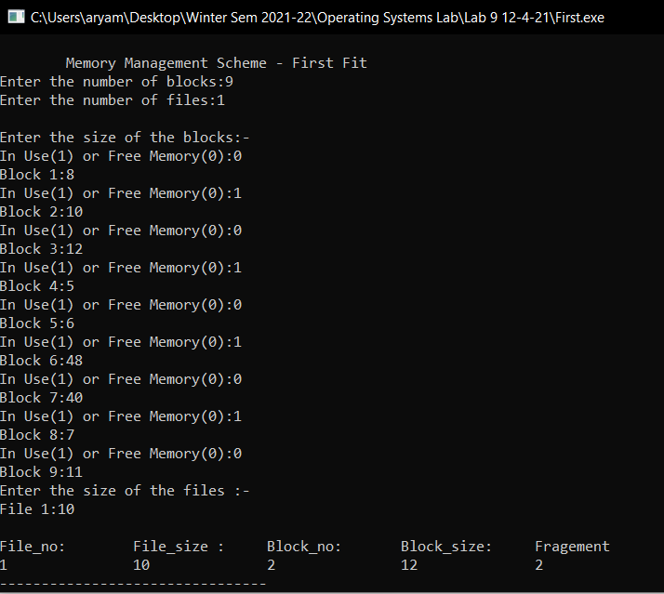

**3)Worst Fit**

#include<stdio.h>

#include<conio.h>

#define max 25

int main()

{

int frag[max],b[max],f[max],i,nb,nf,temp,highest=0,x,j=0,alloc[max];

static int bf[max],ff[max];

printf("\n\tMemory Management Scheme - Worst Fit");

printf("\nEnter the number of blocks:");

scanf("%d",&nb);

printf("Enter the number of files:");

scanf("%d",&nf);

printf("\nEnter the size of the blocks:-\n");

for(i=1;i<=nb;i++)

{

printf("In Use(1) or Free Memory(0):");

scanf("%d",&x);

if(x==0)

{

printf("Block %d:",j+1);

scanf("%d",&b[j]);

j++;

}

else

{

printf("Block %d:",j+1);

scanf("%d",&alloc[i]);

j++;

}

}

printf("Enter the size of the files :-\n");

for(i=1;i<=nf;i++)

{

printf("File %d:",i);

scanf("%d",&f[i]);

}

for(i=1;i<=nf;i++)

{

for(j=1;j<=nb;j++)

{

if(bf[j]!=1) //if bf[j] is not allocated

{

temp=b[j]-f[i];

if(temp>=0)

if(highest<temp)

{

ff[i]=j;

highest=temp;

}

}

}

frag[i]=highest;

bf[ff[i]]=1;

highest=0;

}

printf("\nFile_no:\tFile_size :\tBlock_no:\tBlock_size:\tFragement");

for(i=1;i<=nf;i++)

printf("\n%d\t\t%d\t\t%d\t\t%d\t\t%d",i,f[i],ff[i],b[ff[i]],frag[i]);

getch();

return 0;

}

